Table of Contents

1，Prepare a disk use for ISCSI share 0

2,Install targetcli 0

3,Configure targercli 0

4, Client access iSCSI storage 1

4.1, Install iscsi-initiator-utils 1

4.2, Configure initiatorname.iscsi 2

4.3，查看目标存储 2

4.4, Login iScsi 2

4.5, 查看核对登录信息 2

4.6, Check disk status 2

# 1，Prepare a disk use for ISCSI share

Look at here, This 20G part is I ready to use for ISCSI share.

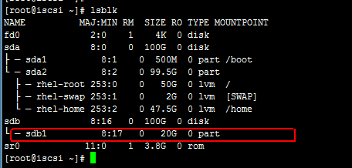

# 2,Install targetcli

# yum install targetcli -y

# 3,Configure targercli

[root@iscsi ~]# targetcli

targetcli shell version 2.1.fb41

Copyright 2011-2013 by Datera, Inc and others.

For help on commands, type 'help'.

/> /backstores/block create block1 /dev/sdb1

Created block storage object block1 using /dev/sdb1.

/> iscsi/ create iqn.2016-09.pub.alv:remotedisk1

Created target iqn.2016-09.pub.alv:remotedisk1.

Created TPG 1.

Global pref auto_add_default_portal=true

Created default portal listening on all IPs (0.0.0.0), port 3260.

/> cd iscsi/iqn.2016-09.pub.alv:remotedisk1/tpg1

/iscsi/iqn.20...otedisk1/tpg1> acls/ create iqn.2016-09.pub.alv:svn

Created Node ACL for iqn.2016-09.pub.alv:svn

/iscsi/iqn.20...otedisk1/tpg1> portals/ create 192.168.105.33 3260

Using default IP port 3260

Created network portal 192.168.105.33:3260.

/iscsi/iqn.20...otedisk1/tpg1> luns/ create /backstores/block/block1

Created LUN 0.

Created LUN 0->0 mapping in node ACL iqn.2016-09.pub.alv:svn

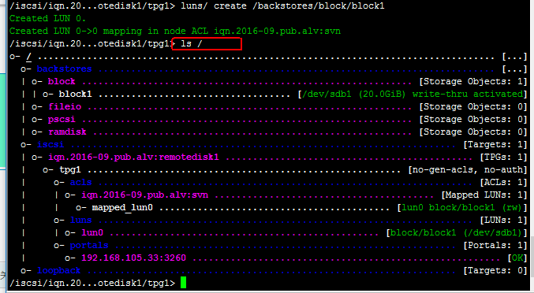

/iscsi/iqn.20...otedisk1/tpg1> cd /

/> saveconfig

Last 10 configs saved in /etc/target/backup.

Configuration saved to /etc/target/saveconfig.json

/>exit

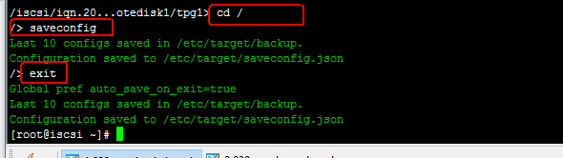

# systemctl start target.service

[root@iscsi ~]# firewall-cmd --permanent --add-port=3260/tcp

success

[root@iscsi ~]# firewall-cmd --reload

Success

# 4, Client access iSCSI storage

## 4.1, Install iscsi-initiator-utils

[root@svn ~]# yum install iscsi-initiator-utils

## 4.2, Configure initiatorname.iscsi

[root@svn ~]# vi /etc/iscsi/initiatorname.iscsi

InitiatorName=iqn.2016-09.pub.alv:svn

## 4.3，查看目标存储

[root@svn ~]# iscsiadm -m discovery -t sendtargets -p 192.168.105.33

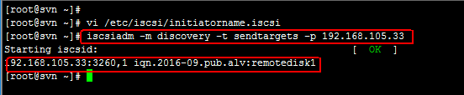

## 4.4, Login iScsi

[root@svn ~]# iscsiadm -m node --targetname iqn.2016-09.pub.alv:remotedisk1 --portal 192.168.105.33 --login

Logging in to [iface: default, target: iqn.2016-09.pub.alv:remotedisk1, portal: 192.168.105.33,3260] (multiple)

Login to [iface: default, target: iqn.2016-09.pub.alv:remotedisk1, portal: 192.168.105.33,3260] successful

## 4.5, 查看核对登录信息

[root@svn ~]# iscsiadm -m session -o show

tcp: [1] 192.168.105.33:3260,1 iqn.2016-09.pub.alv:remotedisk1 (non-flash)

## 4.6, Check disk status

[root@svn ~]# lsblk

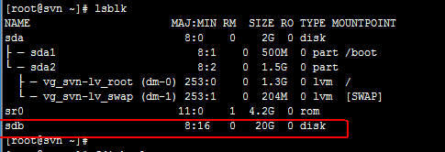

4.7, use this disk

# fdisk /dev/sdb

4.8, Setup automatic start

[root@svn ~]# chkconfig iscsi on

[root@svn ~]# chkconfig iscsid on

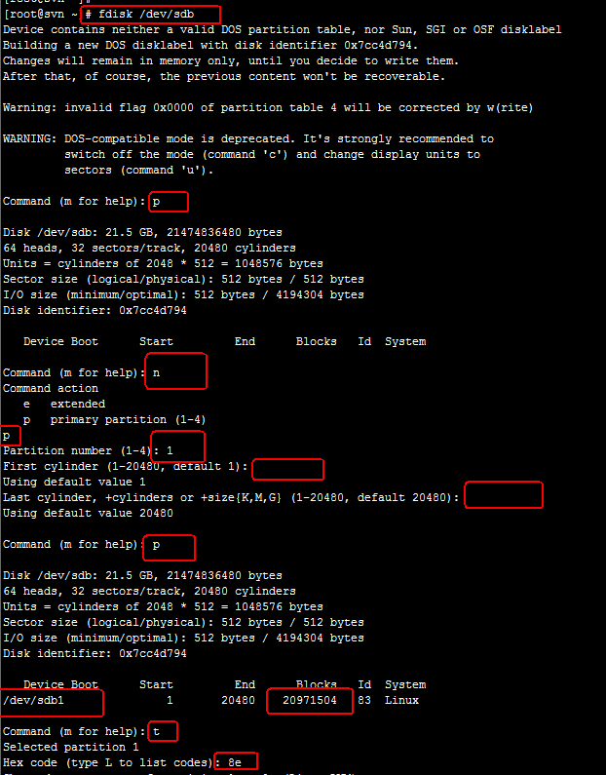

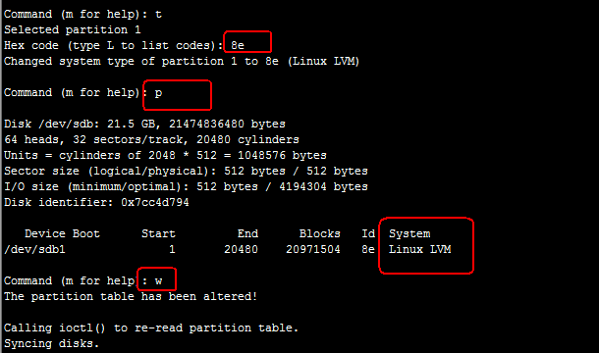

Something

[root@svn ~]# pvcreate /dev/sdb1

[root@svn ~]# vgs

VG #PV #LV #SN Attr VSize VFree

vg_svn 1 2 0 wz--n- 1.51g 0

[root@svn ~]# vgextend vg_svn /dev/sdb1

Volume group "vg_svn" successfully extended



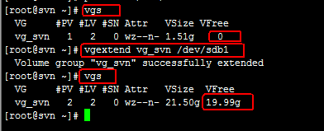

Extend lv

